ARTIFICIAL INTELLIGENCE

Assignment- 1

AI Voice-Controlled Home Assistant

Submitted By ELDHO BINU GROUP 12
S7 CSEA
Roll No:27

AI Voice-Controlled Home Assistant

Introduction
This report presents the design and implementation of an intelligent AI agent that controls home appliances through natural voice commands, featuring real-time speech recognition, natural neural voice responses, and a modern graphical user interface. The system enhances user convenience, accessibility and energy management by accurately interpreting spoken instructions, maintaining conversational context, and providing clear spoken feedback while operating under the uncertainty of real-world acoustic environments.

PEAS Description

Component | Description
Performance Measure | - Speech recognition & intent accuracy  - Correct appliance action execution rate  - Response latency and naturalness of spoken feedback  - Minimization of false activations  - User satisfaction and energy savings
Environment | Multi-room smart home with IoT appliances (lights, fans, ACs, TVs, plugs), ambient noise, multiple users, varying acoustic conditions and continuous device state changes. Interaction occurs through microphone and speakers.
Actuators | - Text-to-speech engine (neural female voice) for spoken replies  - Appliance controllers (simulated / IoT ready)  - Graphical UI updates (device status, conversation history)
Sensors | - Microphone for continuous voice capture  - Automatic Speech Recognition (Google ASR)  - Appliance state sensors (on/off, temperature, brightness, volume)

Environment Classification

Property | Class | Justification
Observability | Partially Observable | Background noise, accents and incomplete utterances prevent perfect perception of intent.
Determinism | Stochastic | ASR errors and unpredictable user phrasing make outcomes probabilistic.
Episode | Sequential | Commands depend on prior context (“turn it off”). Dialogue state is maintained.
Dynamism | Dynamic | Device states, noise levels and user presence change independently over time.
Continuity | Discrete actions | Control actions are discrete; continuous signals exist at the audio sensor level.
Agents | Single-Agent | One assistant agent interacts with multiple users and devices.

Rationality Measure
A rational agent selects actions that maximize expected performance. The Voice Home Assistant achieves rationality by: (1) converting speech to text via ASR, (2) extracting intent and entities with a rule-based NLU layer, (3) resolving ambiguous references using dialogue context (last device and room), (4) applying safety checks and device constraints before acting, and (5) giving clear spoken confirmation so the user can correct errors. When confidence is low the agent asks for clarification instead of risking an incorrect action. This policy maximizes successful executions while minimizing unsafe or unwanted changes.

Innovation Points

Three innovative features are implemented beyond basic voice control systems: (1) a modern graphical UI that shows live device states and conversation history for transparency and usability; (2) high-quality neural text-to-speech (edge-tts with a natural female voice) that replaces robotic SAPI voices; (3) context-aware sequential reasoning that correctly handles incomplete commands such as “turn it off” or “increase the AC”. These features improve naturalness, user trust and practical usability of the smart-home assistant.

System Architecture Diagram

User speaks into Microphone
↓
Speech Recognition (Google ASR)
↓
NLU – Intent & Entity Extraction + Context
↓
Rational Decision Engine + Safety Rules
↓
Actuators: Update Appliance States + Speak Reply (Neural TTS) + Update UI
Figure 1: Architecture – Sensors → Reasoning → Actuators (Voice + UI)

Conclusion

The implemented AI Voice-Controlled Home Assistant is a complete rational agent that listens through a microphone, interprets natural language commands, maintains context, controls appliances and replies with a natural female neural voice, all inside a modern graphical interface. The design successfully handles partial observability and stochastic speech recognition while offering a practical and user-friendly foundation for real smart-home applications.

Simulation
A fully working Python application was developed. It uses the system microphone for continuous listening, Google Speech Recognition for ASR, a rule-based NLU engine with context, and high-quality neural TTS (edge-tts) for spoken replies. A CustomTkinter graphical interface displays conversation history, live device status and listening state. The same logic also works in pure console mode. Students can run the program, issue voice commands and capture screenshots of both the UI and the terminal for submission.

Full Source Code
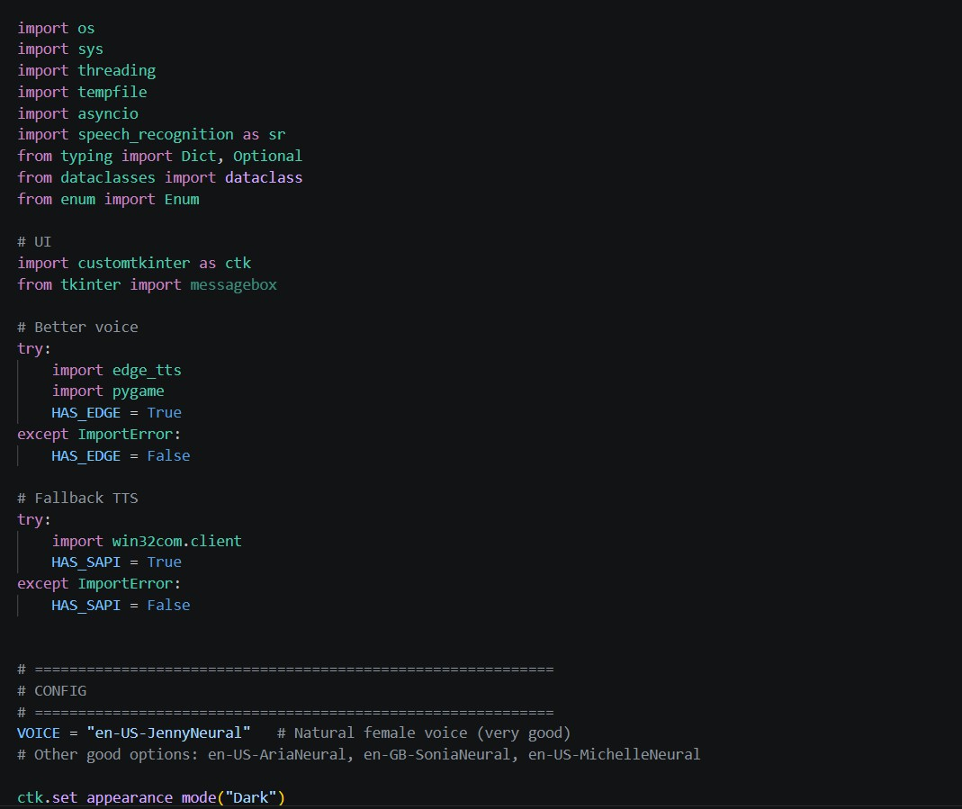

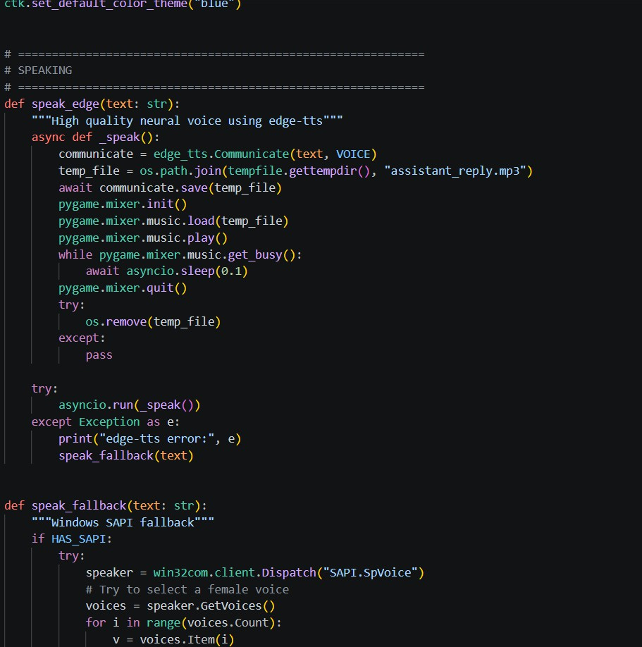

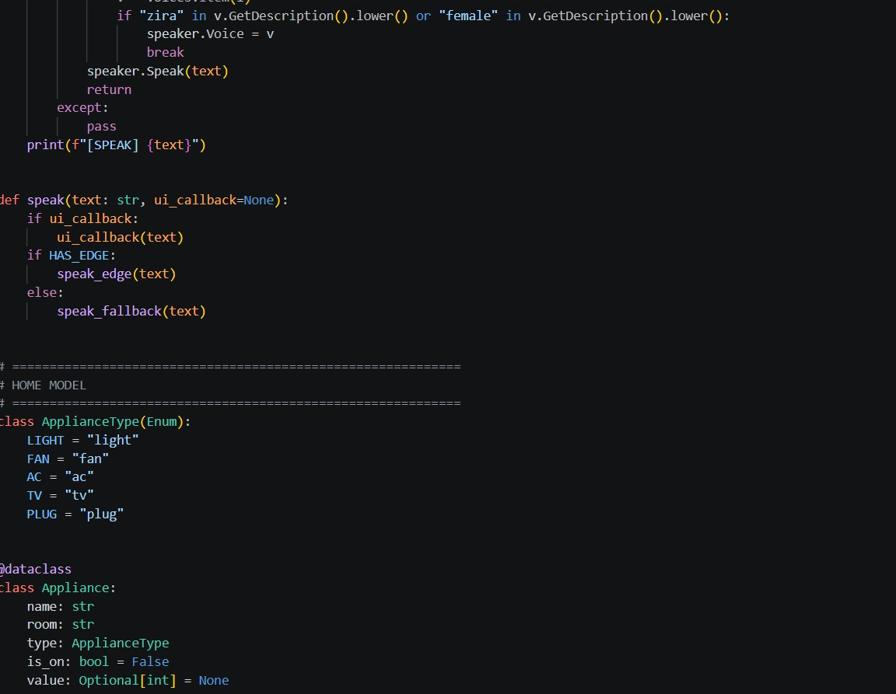

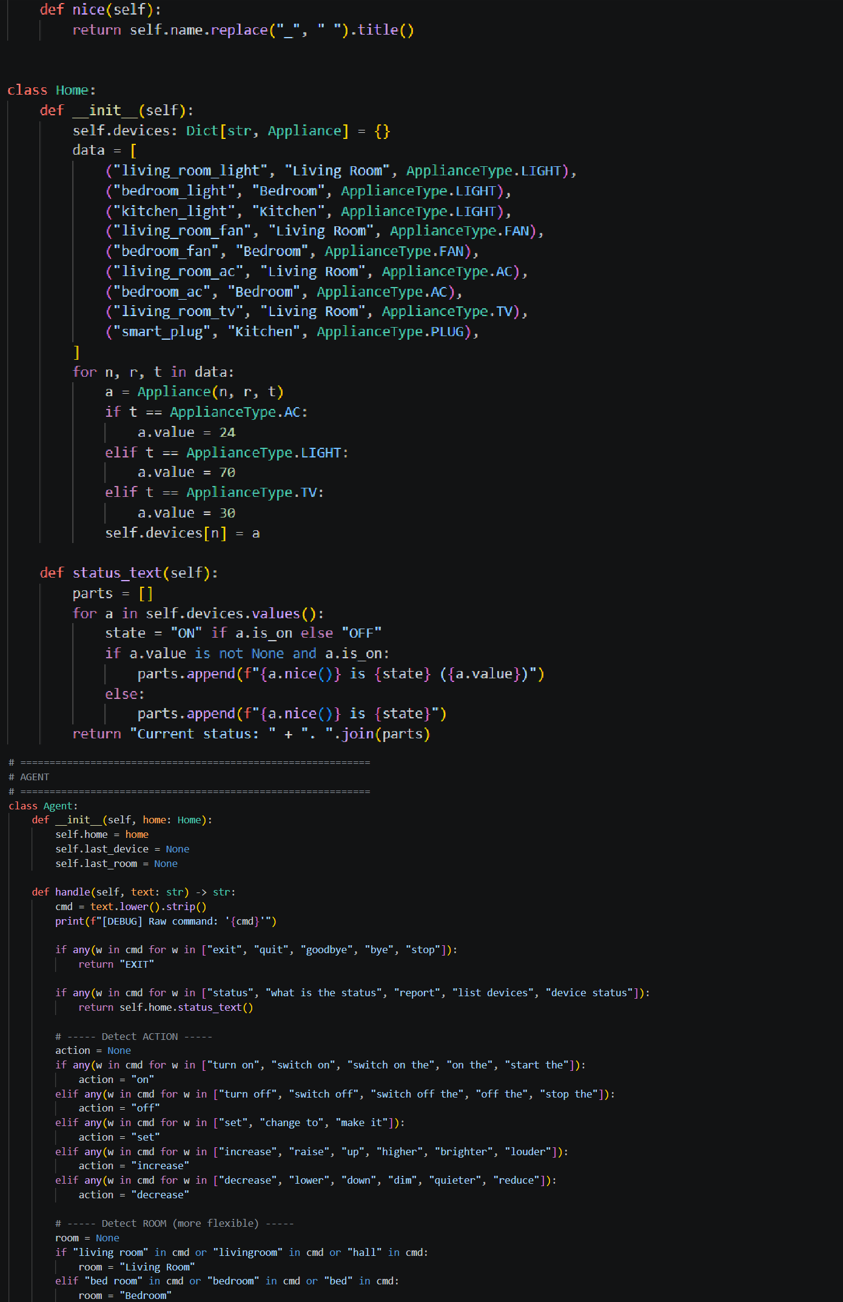

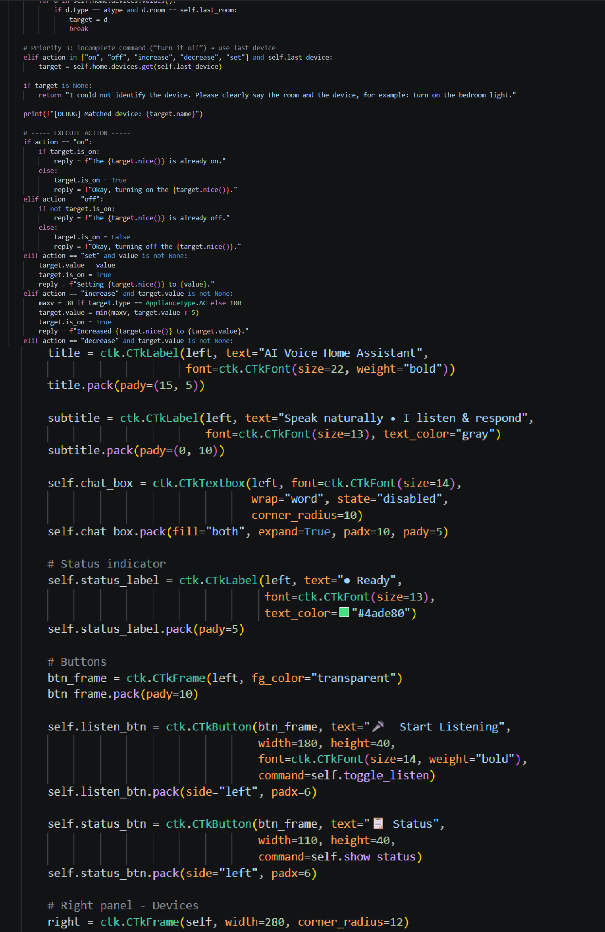

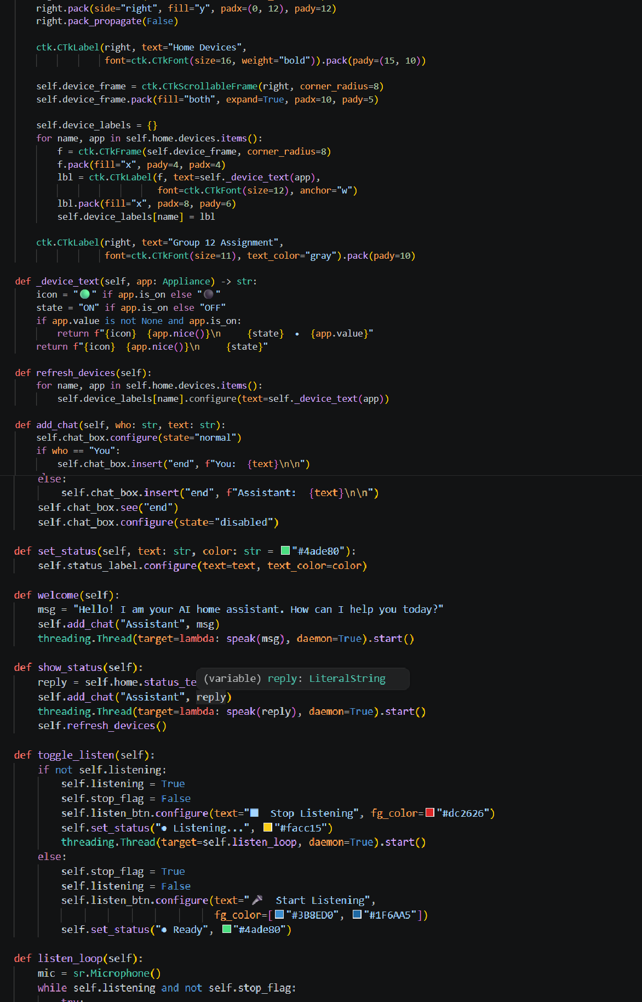

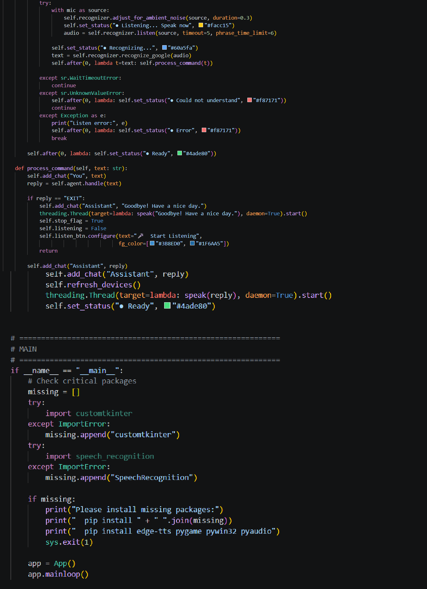

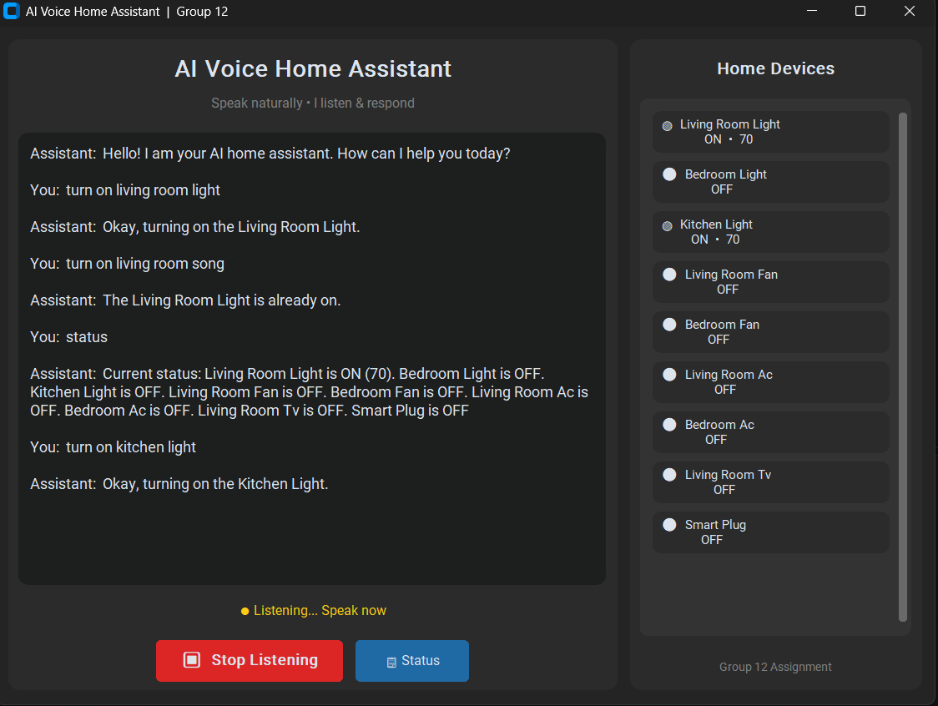

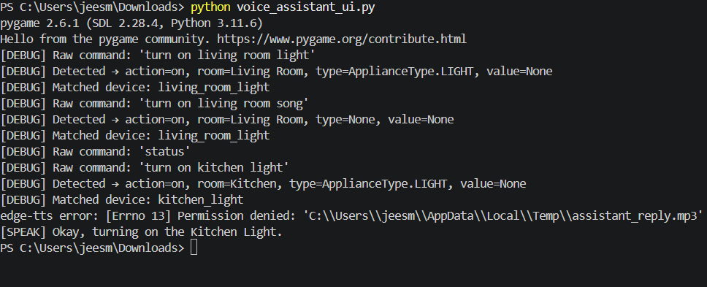
- OUTPUT

When the application starts, the assistant greets the user with a natural female voice and the UI appears.

